Task 3

Documentation

PROG6212

12001640

Grant Verheul

Contents

Vision Statement 2

Project Charter 2

Goals and Objectives 2

Scope 2

System Requirements Specification 2

Functional Requirements 2

Non-Functional Requirements 3

Flow Chart 4

UML 9

Use Case 10

Screenshots 11

Test Data 12

# Vision Statement

This project is for lecturers to make a multiple-choice test, students to take the multiple-choice test and for access to the respected memos. The application should:

* allow a lecturer to set up a single multiple-choice test;
* Allow a learner to take the test;
* Once the learner has completed the test show the final mark, as well as the memorandum.
* Multithreading
* Generic lists
* Polymorphism
* Dynamic Link Libraries or DLLs
* Access a database using ADO.NET connected or disconnected layer

# Project Charter

## Goals and Objectives

Present lecturers with an easy and intuitive way to create multiple-choice tests and view overall marks while giving the students the ability to take the tests previously setup by the respected lecture as well as view a memo after taking the test.

## Scope

* C# web application using the ASP.NET programming AP
* Allow a user to login and redirect to the correct form – username and password
* Allow a lecturer to login and redirect to the correct form – username and password
* Allow a lecturer to create a multiple-choice test – create question with four multiple choice answers with one of the answers ticked to indicate the correct answer.
* Allow a student to take the multiple-choice test – by ticking the appropriate box and clicking next for the next question.
* Allow a student to view a memo after taking the test – indicating questions, possible answers, correct answer, as well as learner’s answer and mark including cumulative mark out of total potential marks.
* Allow a lecture to view marks of all students who have taken the test – mark, average mark, highest mark and lowest mark.

# System Requirements Specification

## Functional Requirements

Requirements set out in the scope to all be met.

## Non-Functional Requirements

* User login.
* Try Catch statements to resolve errors.
* Disconnected database layer to attempt to capture data in the event of database disconnection.
* Registration of new users

# Flow Chart

Input username

Input password

“user in database” clicked?

Register()

username or password exist in the database?

Is the username and password correct?

TakeTest()

Is the user a student or a lecturer?

CreateQuestionnaire()

No

Yes

No

Yes

Yes

Display “Username or password is incorrect”

Student

No

Lecturer

Set UserType to “S”

Write Firstname, Surname, email and ID into lecturer table

Set UserType to “L”

Write Firstname, Surname, email and ID into student table

Has the user clicked the Lecturer button

Input username

Input password

Input Firstname

Input Surname

Input Email

Input ID

Write Username, password into user table

Login()

Yes

Yes

No

Insert moduleCode

Insert testNumber

Insert Question

Insert QA

Insert QB

Insert QC

Insert QD

Insert corrAns

Insert Questionnumber++

Is “Save Question” button clicked

Does the user Exit?

Hide testNumber

Hide moduleCode

Clear Question

Clear QA

Clear QB

Clear QC

Clear QD

Clear corrAns

Save mouleCode, testNumber, Question, QA, QB, QC, QD, and corrAns to a database

Display “Question saved”

No

Yes

Yes

Insert Code

Insert testNumber

Set QNum = 1

Set mark = 0

Select Question from database were Questionnumber = QNum++

Set lblQuestion = Question

Set lblQA = QA

Set lblQB = QB

Set lblQC = QC

Set lblQD = QD

Set correctAns = CorrAns

Insert Selected answer

Set Ans = selected answer

Are Ans and correctAns the same

Mark increment by 1

When next Question button clicked

Is there another question in the database?

Display “The questionnaire is complete” + mark

Memo()

Yes

No

Yes

No

Display All the Data from the database where the Code and test number match the input

# UML

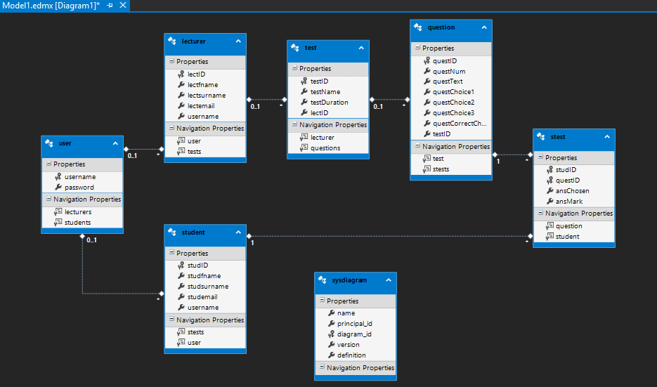

# Use Case

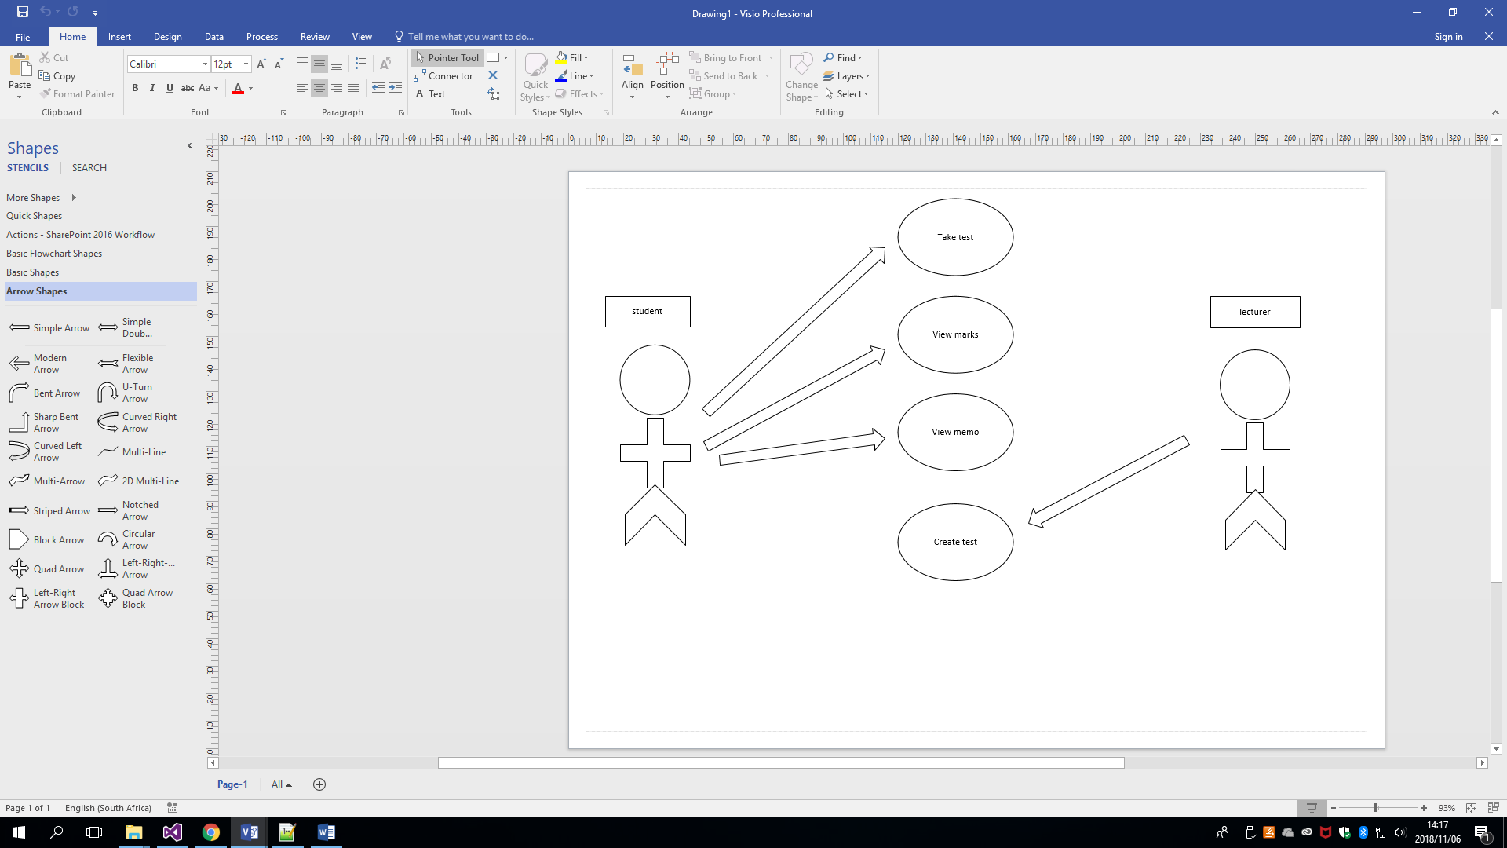

# Screenshots

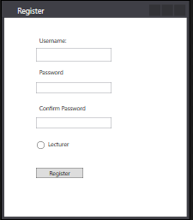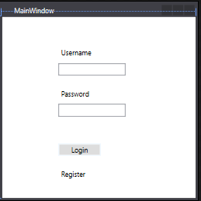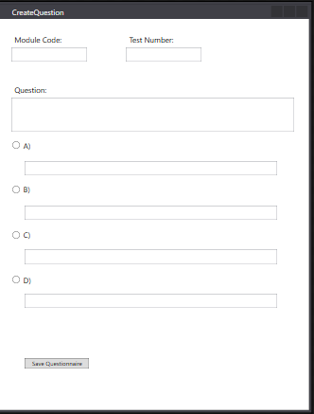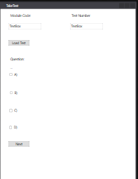

# Test Data

Create Test data:

Code: 1

Test Number: 1

Question: “What colour is the sky?”

QA: “Blue”

QB: “Green”

QC: “Red”

QD: “Orange”

CorrectANS: QA

Question: “What colour is the ocean?”

QA: “Brown”

QB: “Blue”

QC: “Pink”

QD: “Purple”

CorrectANS: QB

Question: “What colour is the grass?”

QA: “Blue”

QB: “Orange”

QC: “Green”

QD: “Maroon”

CorrectANS: QC

Student data entered taking test:

Code: 1

Test Number: 1

CorrectANS: QA

Code: 1

Test Number: 1

CorrectANS: QB

Code: 1

Test Number: 1

CorrectANS: QD

Mark should be 2/3.